USER MANUAL FOR “ADMIN”

“LIMITER”

THE SMART PARKING SYSTEM

**1. Services Needed :**  
As the application is not submitted at any authorized source, the user will be needed to allow installation from unknown sources to install our application.  
  
**2. Permissions :**  
We will not be needing any permissions in this application  
  
**3.Launch Page :**  
Any user will be directed to the launch page after opening the application where they will have to choose in which mode they want to run the application (i.e user or admin). In this case we will only consider Admin.

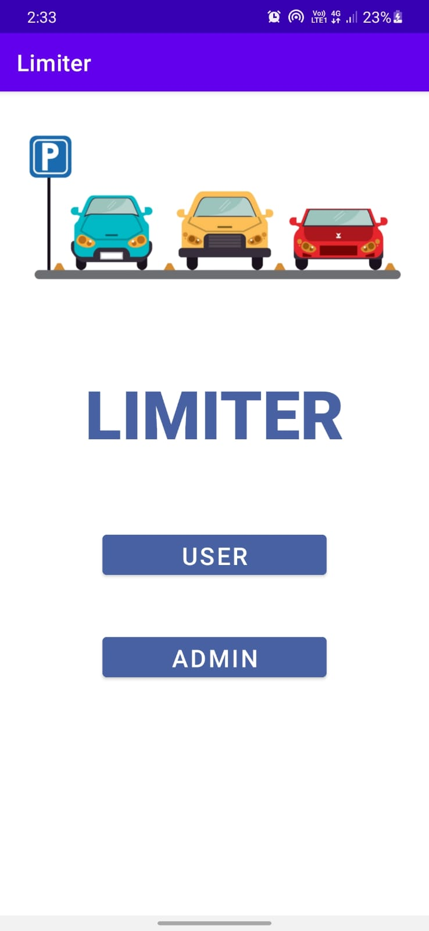

**4. Admin Login :**

If one decides to run the application in the admin mode and clicks on “ADMIN” , the app will be redirected to the admin login.  
  
There are two cases here: 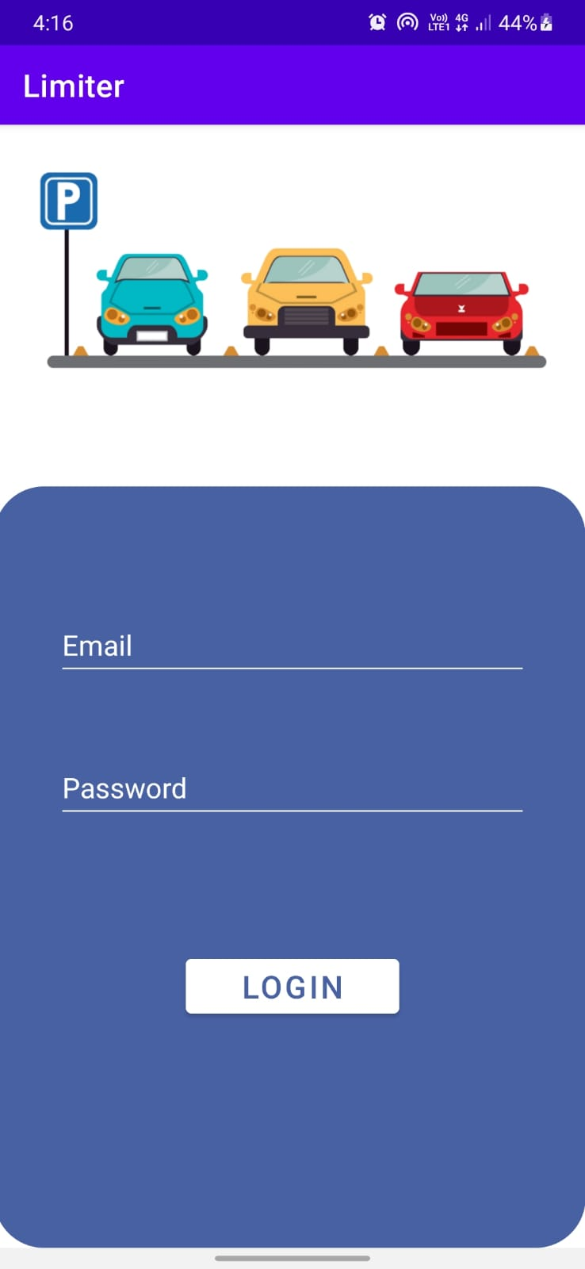

1. The user may enter the proper credentials , in that case we will redirect the admin to the landing page.

{

To test this functionality ,use the credentials of any of the following accounts:

**Email id:** iit2020191@iiita.ac.in **Password:** admin@191

**Email id:** iit2020193@iiita.ac.in **Password:** admin@193

**Email id:** iit2020194@iiita.ac.in **Password:** admin@194

**Email id:** iit2020195@iiita.ac.in **Password:** admin@195

}

1. The admin may enter wrong credentials, in this case admin will be redirected to the login page with a toast of wrong credentials.

**5. Display Parking :**

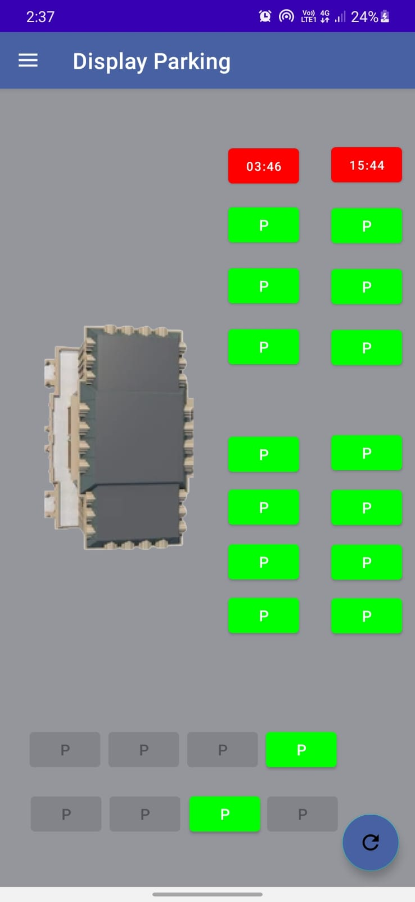

Helps the admin to view the current status of the parking slot.

**6. FAQ**

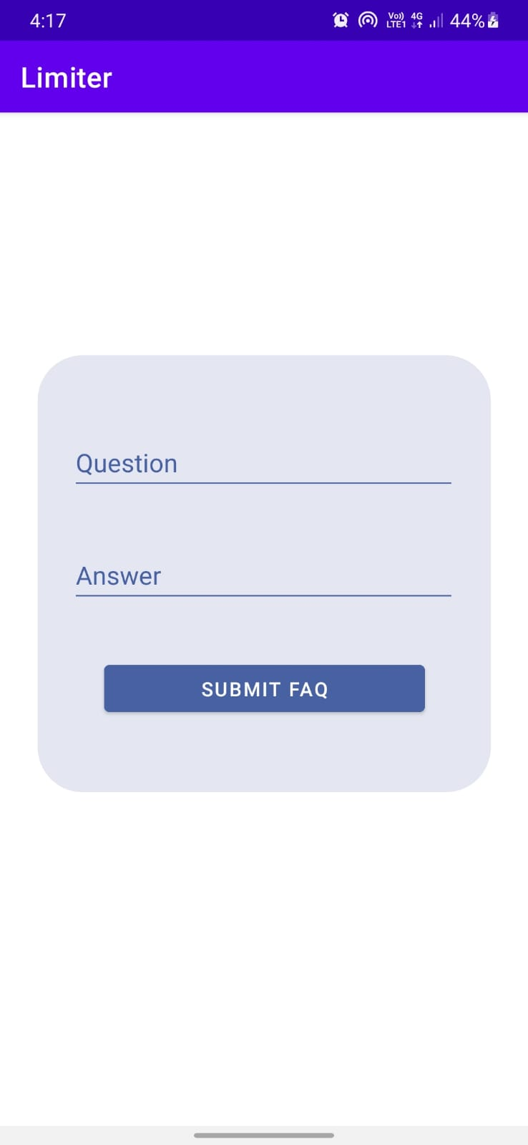

* Admin can add new Questions and Answers for helping users by writing a Question in the question dialog box and the relevant answer in the answer dialog box.
* After filling all the details click on the “SUBMIT FAQ” button to add in the FAQ list .

**7. Add slot :**

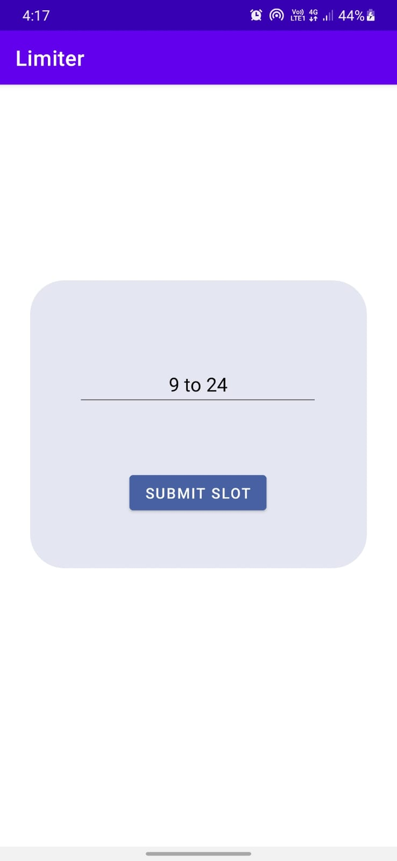

Admin can add a new parking slot if available in the given vicinity.

**8. Set time limit for slots :**

Admin can change the maximum time a user can increase the parking timer according to the vehicle type of the given vehicle.

